Create Rest Template

- Create provider: អ្នកអោយ API គេទៅប្រើ
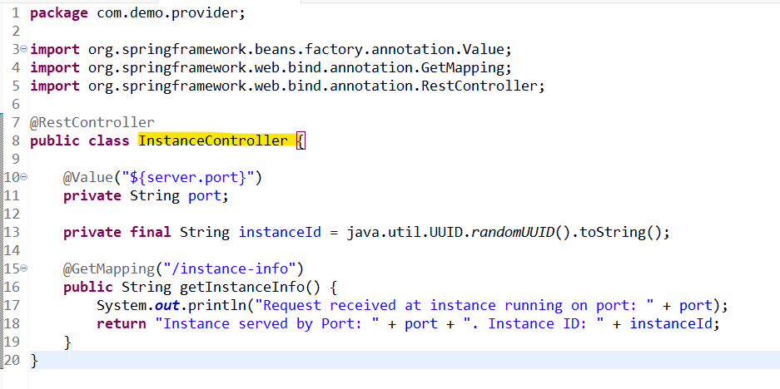

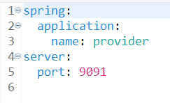

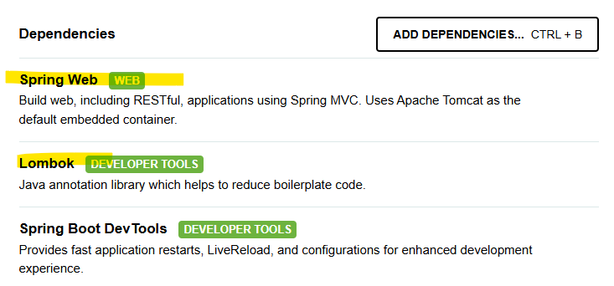

http://localhost:9091/instance-info

- Create Consumer
- Create controller:
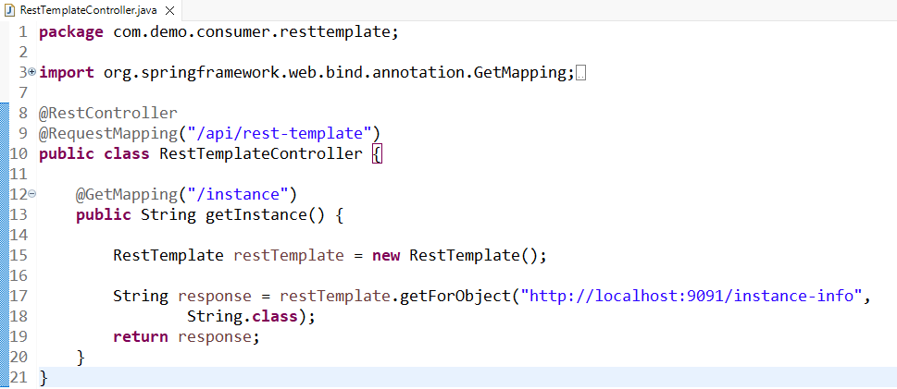

RestTemplate restTemplate = new RestTemplate(); this is we hard coding to crate object.

- We will create spring bean for restTempate.
- What we will create: configuration សម្រាប់បង្កើត Spring Bean and Service to point to the url that we want to use.
